NEW VIDEO CHAT & LAYOUT DESIGN This report is mostly focusing on ***3 things***, namely, the new designs of ***“Mechanics of Video”***, ***“Participant & Chat - the Side Menu”*** and “***Bottom Main Menu***”. From below, I added a graphic of the finished product   
  
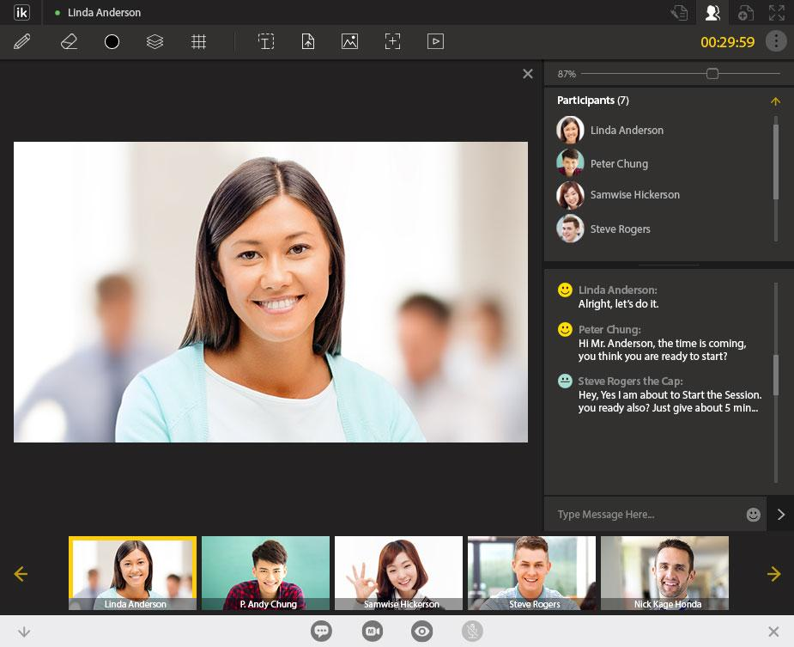  
*Finished design of what it will looks like*

1. **Bottom Menu Bar**Now, we have a different ***layout/design*** for the ***bottom menu***. Please read through carefully, and apply them.   
     
   **MAIN FUNCTIONS**:   
     
   (1) **Collapse and Open**: This will ***Collapse*** the *bottom menu*, and ***Open*** again.  
     
   (2) **Participants & Chat**: This will trigger “***ON and OFF***” of the “***Side Menus***”, that has both “***Participant***” and “***Chat***” together.  
     
   (3) **Video Mode Switcher**: This will start the “***Video Modes***”. These include, “***Video Slides of Participants***”, and “***Divided Screen of Participants***” etc. (*will talk about more later*)  
     
   (4) **Video View ON or OFF**: This will turn your video “***ON or OFF***”. When it is set to “***OFF***”, other participants can’t see you. When it is set to “***ON***” other participants can see you.  
     
   (5) ***Microphone***: This will turn your Microphone “***ON or OFF***”. When it is set to “***OFF***”, other participants can’t hear you. But, you can still hear them. When it is set to “***ON***”, all of the participants can hear you.   
     
   (6) **Close Online Notepad**: This will ***End*** the ***Online Notepad*** (*will close the browser*).   
   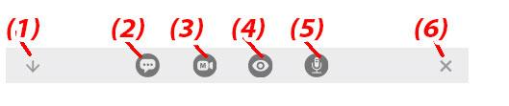  
   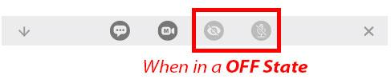  
     
   **DESIGN GUIDE**:   
     
   ***Size***, ***Colors,*** and ***Orientations*** are different from what we had before. Please read through carefully, and apply them.   
   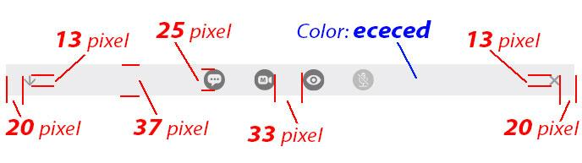  
   ***Middle Icon Sets*** are Always located at the ***Center***. And from further ***Collapse*** and ***Close*** Icons are Always located at the ***Left*** and ***Right*** respectively.   
   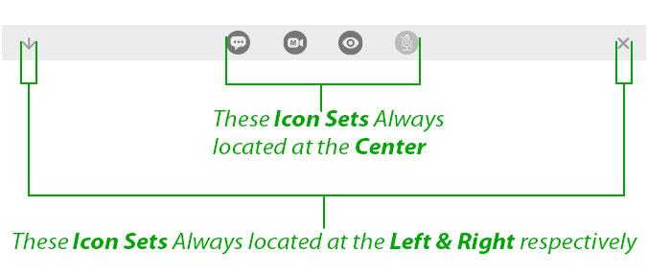
2. **Side Menu**  
     
   Now, we changed the overall ***color theme*** to ***dark*** mode that matches ***top*** and ***video mode***. Main takeaway is that the “***Participants***” and “***Chat***” sections are One Section. And instead of closing the “***Participants***”, it is now ***Collapsable***. Please read through carefully, and apply them.   
     
   **COLLAPSABLE BAR**:   
     
   (1) Now, ***Participants Part*** can be ***Collapsed*** by clicking on the ***Arrow Icon***. It can be ***Reopened*** by clicking the ***icon again***.   
   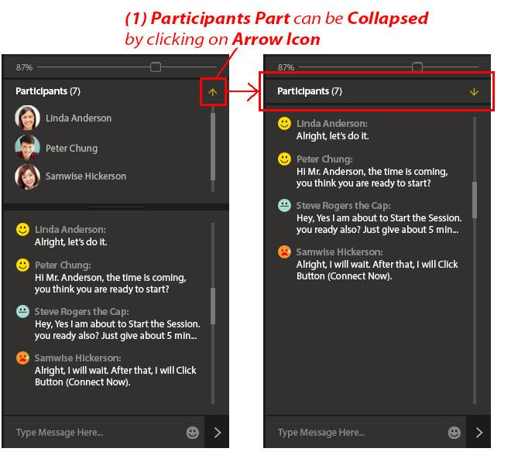  
   (2) ***Middle Handle*** for Each part to be ***Extended*** or ***Dwindle***. (we currently have this functionality).   
   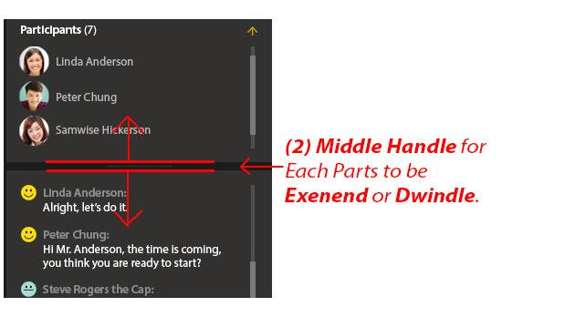  
     
   **OPEN AND CLOSE MENU**:   
     
   (1) When “***Participants & Chat***” is Clicked, it will Trigger “***Side menu***” to “***OPEN***” or “***CLOSE***”.   
   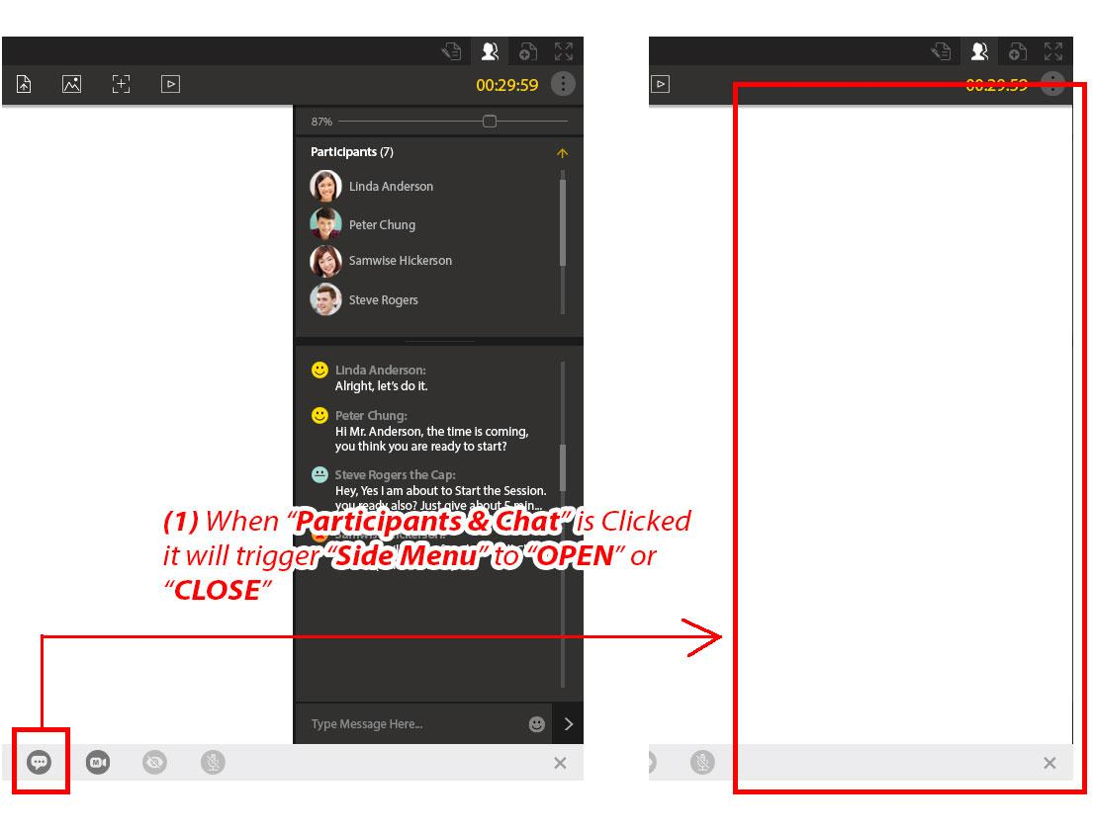  
     
     
   **DESIGN GUIDE**:   
     
   ***Main Type*** and ***Measurements*** for the sides.   
   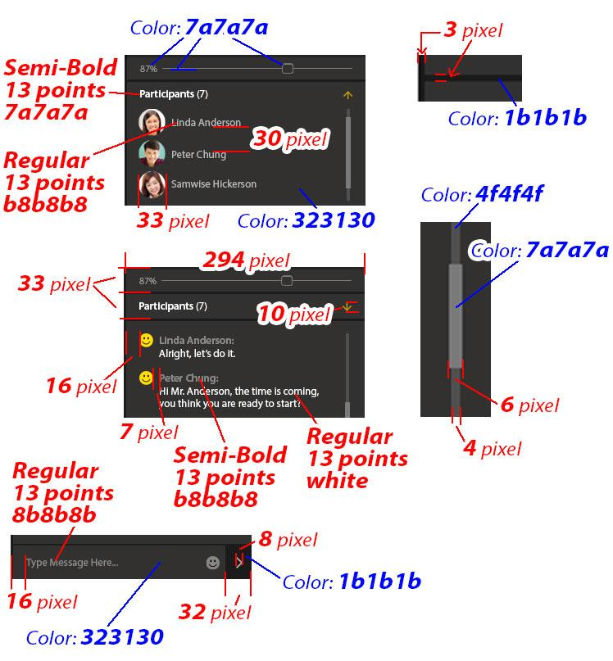  
   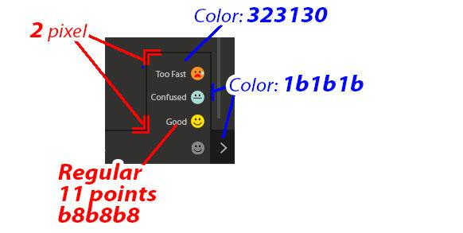
3. **Video Modes Overview**When the user clicks on “***Video Mode Switcher***”, it will show the ***mode options***. When option is Available, it will show in “***Solid Colors***”, if not, it will display as “***Grayed Out Colors***”. More details will be covered later sections.   
     
   (1) It will triggers “***Video Slide***”  
     
   (2) It will triggers “***Video Full Screen***”  
     
   (3) It will trigger “***Active Speaker***”   
   (*“Active Speaker” will “Highlighted” the “Currently Speaking Person”. It can be triggered, when “Slide Mode” or “Full Screen” modes are “ON”.*)  
     
   (4) It will ***Close All Video Modes*** that are currently on the screen.   
   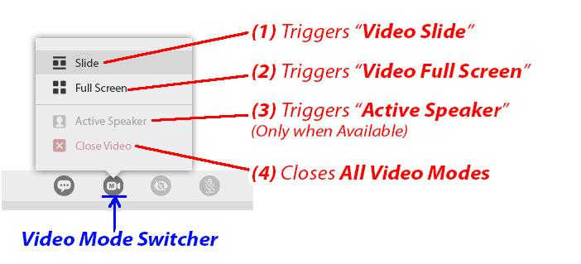  
   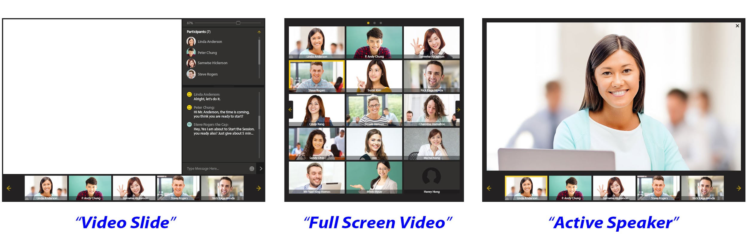  
   *Examples of the Options*
4. **Video Slide Mechanics**When “***Video Slide***” is triggered, the ***Slides Videos*** of ***Participants*** will show up at the bottom, just above the bottom-menu. It can be moved left or right depending on the size of the participants. Please read through carefully, and apply them.  **VIDEO SLIDES**:   
     
   (1) ***Important!***: As a ***Default***, “***Video View***” and “***Microphone***” are ***Turned OFF***. (*note: it can be turned ON anytime during the session*)   
     
   (2) From options, when “***Video Slide***” is Clicked...  
     
   (3) “*At this time, the Side Menu Moves up to make room for Video Slide*”...  
     
   (4) Then, the “***Video Slide***” shows up. It has a ***Video list*** of ***All Participants***. If there are many Participants, it can be moved to left and right to check them all.   
   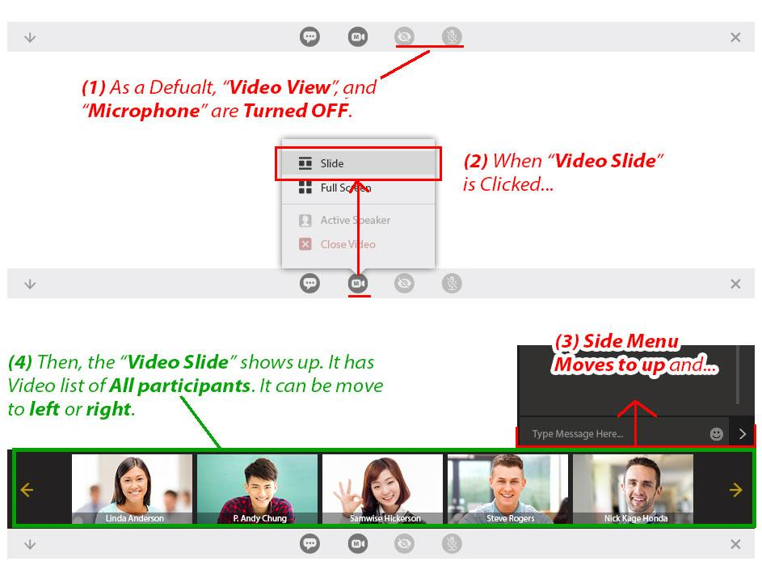  
     
   **ACTIVE SPEAKER**:   
     
   (1) While “***Video Slide***” is still out, click on “***Active Speaker***” again…  
   (*note: since, Slide(or Full Screen) is triggered, the “Active Speaker” option is enabled*)  
     
   (2) Now, it Triggers “***Active Speaker***” ***ON***. What this does is, it shows “***Currently Speaking Person***” ***highlighted***, and shows at the ***Middle of the Screen Fully***. (*note: it* ***detects the sounds****, who is talking at the moment*)   
     
   (3) At this time, from the “***Video Slide***”, the “***Active Speaker***” is ***Highlighted*** with a ***Yellow Colored Frame***. So we know whom, from the Video Slide.   
   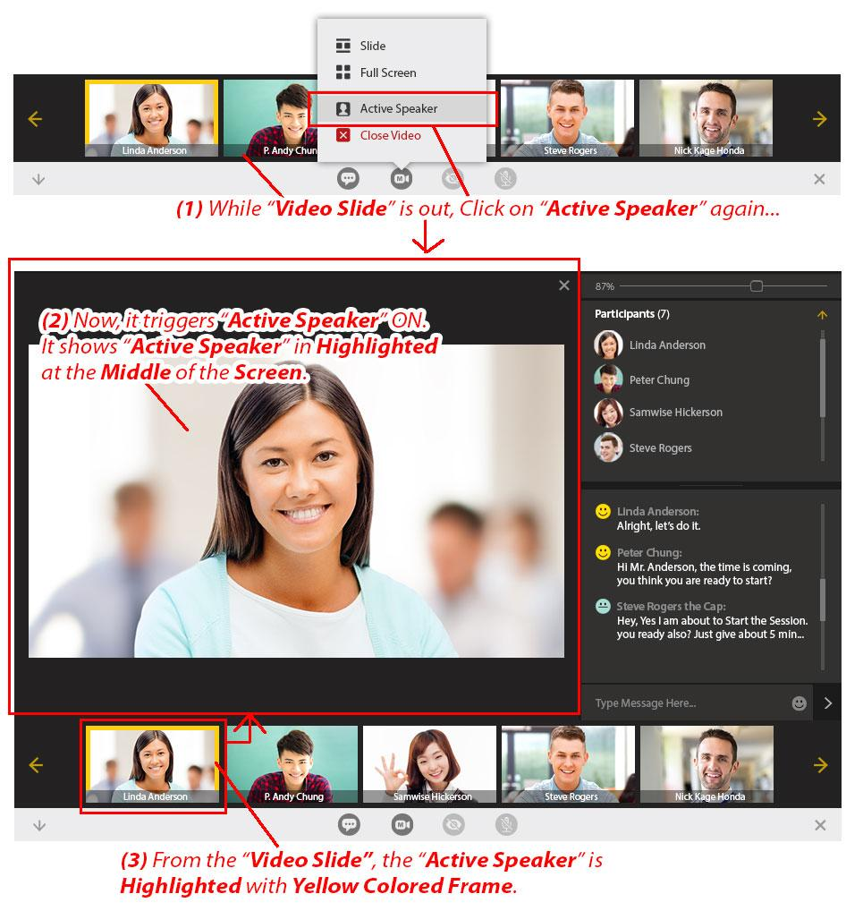  
     
   **DESIGN GUIDE**:   
   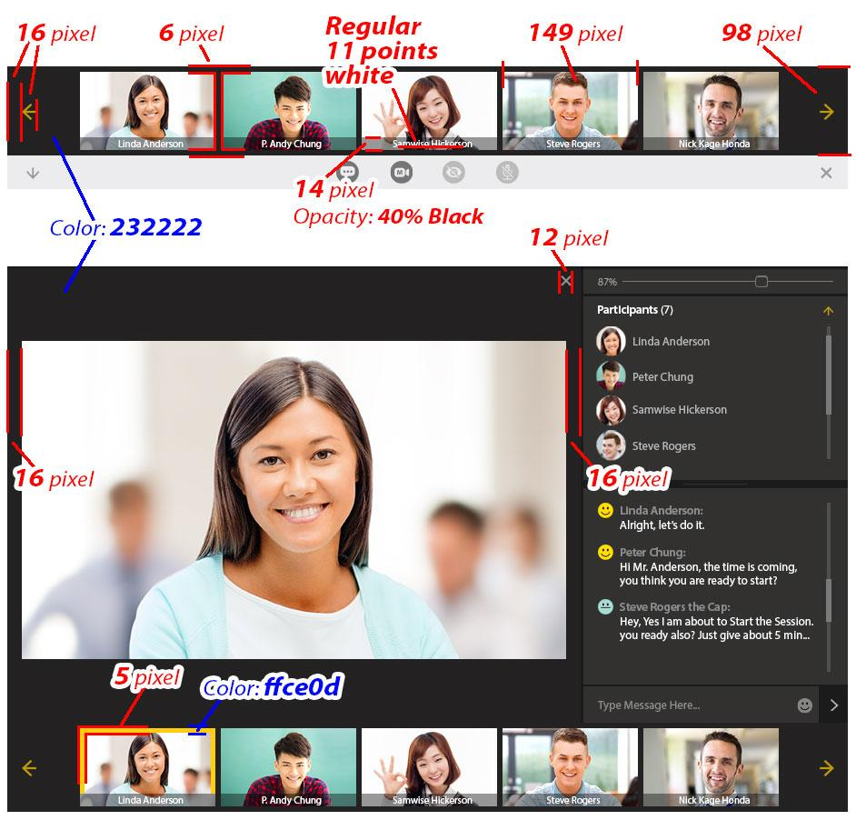  
   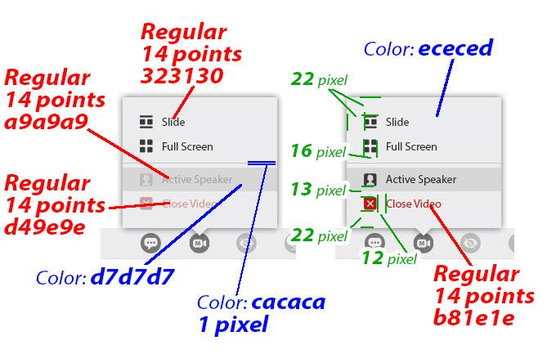
5. **Video Full Screen Mechanics**When “***Full Slide***” is triggered, the ***All*** of ***Participants*** will show up at the ***Main Screen*** divided and occupied fully. It can be moved left or right depending on the size of the participants. Please read through carefully, and apply them.  **BASIC ANATOMY OF FULL SCREEN**:   
     
   (1) From option, when “***Full Screen***” is clicked, the ***Full Screen Mode*** will Activate.  
     
   (2) **Page Indicator**: Number of Dots with One Highlighted shows the current page.   
     
   (3) **Current Speaker**: This will be Highlighted with a Yellow Frame.   
     
   (4) **Move Left & Right**: This will move to Forward or Previous Page.  
     
   (5) **Inactive**: When there’s No One, the Inactive Slot will be Displayed.   
   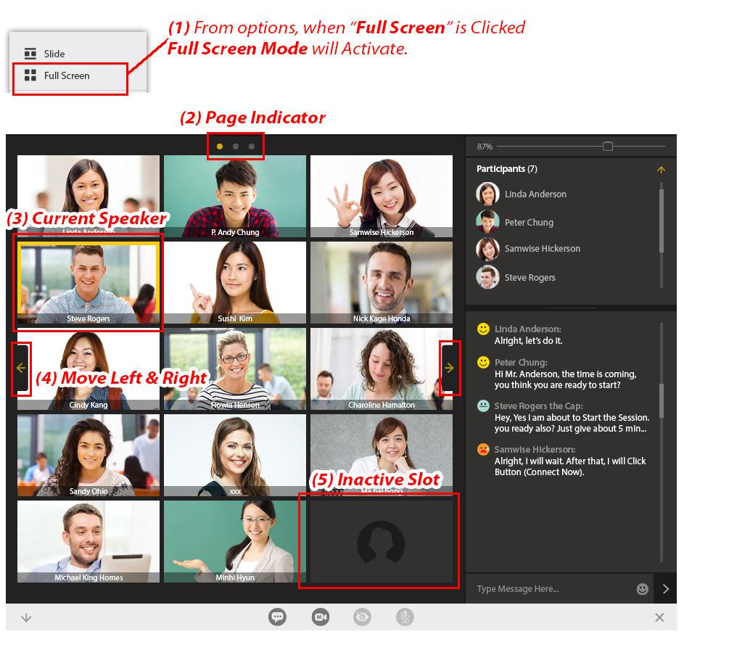  
     
   **SCALE VARIATIONS OF VIDEOS**:   
     
   Depending on how many ***Current Participants***, the ***Size/Scale*** of the ***Videos will differ***. Please read through carefully, and apply them.   
     
   **2 Participants**:   
   Both 2 participant is divided up and down. Noticeably bigger size and occupies the most of the screen space.   
     
   **3~4 Participants**:   
   3 or 4 participants are spread into Two Rows. Notice when it is 3 participants, the Last Box is Grayed Out (*INACTIVE SLOT*: *this acts as Place Filler*). Otherwise All 4 Video Boxes are filled with Participants.   
     
   **5~6 Participants**:  
   5~6 participants are spread into Three Rows. Again, Unused Box will be Grayed Out.   
     
   **7~15 Participants**:  
   7~15 participants are spread into Three ~ Four Rows, depending on the Size of the Participants. Again, Unused Box(*es*) will be Grayed Out (*Some cases, the Grayed Out Boxes could be more than One*).   
   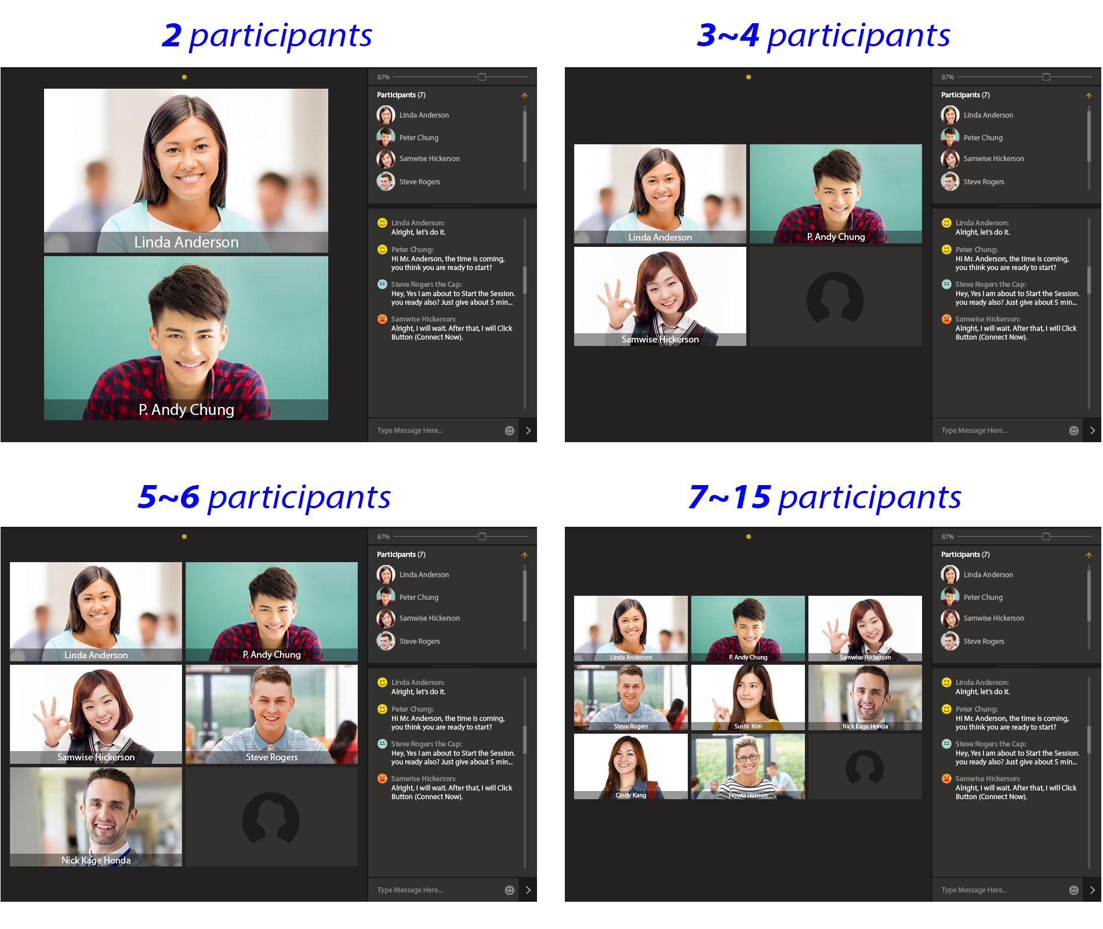  
     
   **SPECIAL RULE**:   
     
   (1) From the “***Full Screen Mode***”, when “***Active Speaker***” is Clicked, it Changes to “***Slide Mode***” with Active Speaker Enabled.   
   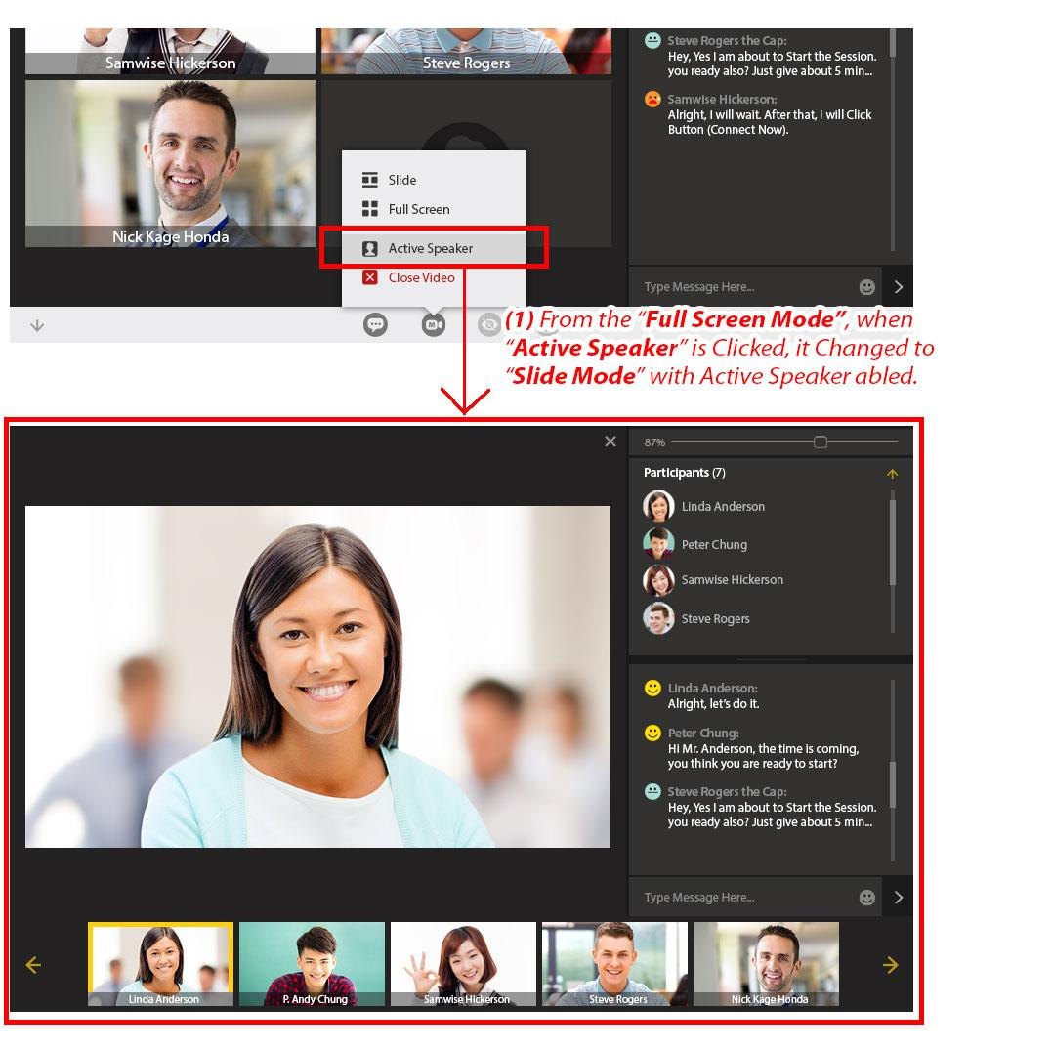  
     
   **DESIGN GUIDE**:   
     
   (1) When it is at “***Full Screen Mode***” Make Sure ***All the Participant Boxes*** are ***Fitted into the “Green Guide Line”*** (***Top/Bottom*** = ***30 pixel***) and (***Left and Right Sides*** = ***16 pixels***).   
     
   *Note*: Make All the Participant Boxes Centered.   
   